1. Cybersecurity Fundamentals

Cybersecurity
Cybersecurity is the practice of protecting systems, networks, and data from digital attacks, unauthorized access, and damage.

CIA Triad - The 3 Core Principles
1. Confidentiality: Ensuring that sensitive information is accessed only by authorized individuals.
2. Integrity: Ensuring that data is accurate and has not been altered by unauthorized persons.
3. Availability: Ensuring that systems and data are accessible to authorized users when needed.

Key Terms
1. Threat: Any potential danger that can exploit a vulnerability to cause harm.
2. Vulnerability: A weakness in a system that can be exploited by a threat.
3. Risk: The potential for loss or damage when a threat exploits a vulnerability.
4. Exploit: A method or code used to take advantage of a vulnerability.

2. Red Team Methodology

Red Team methodology is a structured approach to simulate real-world attacks to test an organization's security.

The 5 main phases are:
1. Reconnaissance: Gathering information about the target system.
2. Scanning and Enumeration: Identifying open ports, services, and vulnerabilities.
3. Gaining Access: Exploiting vulnerabilities to enter the system.
4. Maintaining Access: Establishing persistent access to the target.
5. Analysis and Reporting: Documenting findings and3. Authorization and Scope Document

1. Project Title: Authorized Cybersecurity Lab for Internship
2. Purpose: To practice Red Team methodology in a controlled environment
3. Scope:
• In Scope: Kali Linux VM, Metasploitable2 VM on local network
• Out of Scope: Internet targets, other devices, social engineering
4. Rules of Engagement:
• Testing will only be done on authorized lab VMs
• No data will be stolen or deleted
• Testing hours: 9am to 6pm only
• All findings will be reported
5. Authorization: This lab is set up for educational purpose only by [UROOJ ATIF] for [CYBERSECURITY INTERNSHIP]
6. Date: 10 Sep 2026 providing recommendations.

3. Rules of Engagement & Scope
Target System: Metasploitable2 VM
Target IP: 192.168.56.102
Authorization: This lab is authorized only for educational purpose in isolated environment.
Rules of Engagement:
1. Only scan and test the authorized target 192.168.56.102
2. No attacks on real/public networks or systems
3. Purpose: Learning vulnerability assessment and ethical hacking only
4. Lab Setup & Evidence

Step 1: Set up Kali Linux VM
Step 2: Set up Metasploitable2 VM
Step 3: Connected both VMs on Host-Only Network
Step 4: Ran nmap scan to identify open ports on 192.168.56.102
Step 5: Accessed Metasploitable2 web page via Firefox
Evidence:
Figure 1: nmap scan result
Figure 2: Metasploitable2 web page at http://192.168.56.102

Evidence:
Figure 1: Kali Linux IP Address - 192.168.56.101
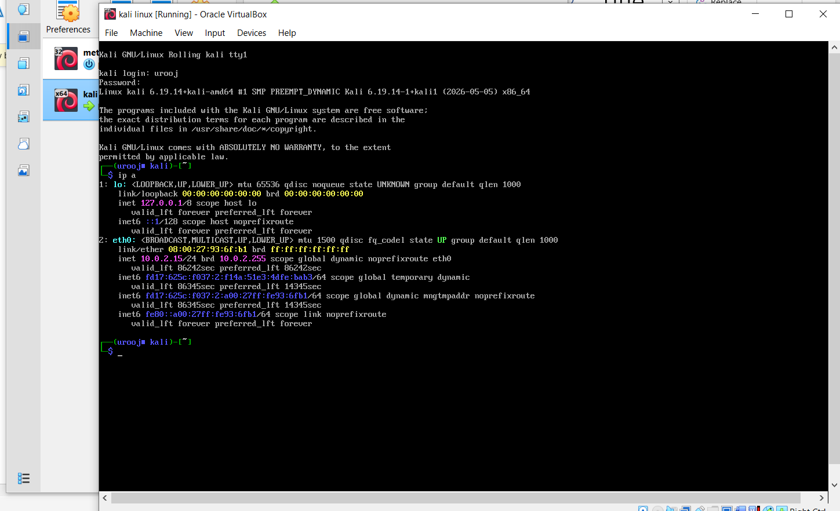

Figure 2: Metasploitable2 VM IP & Web Page
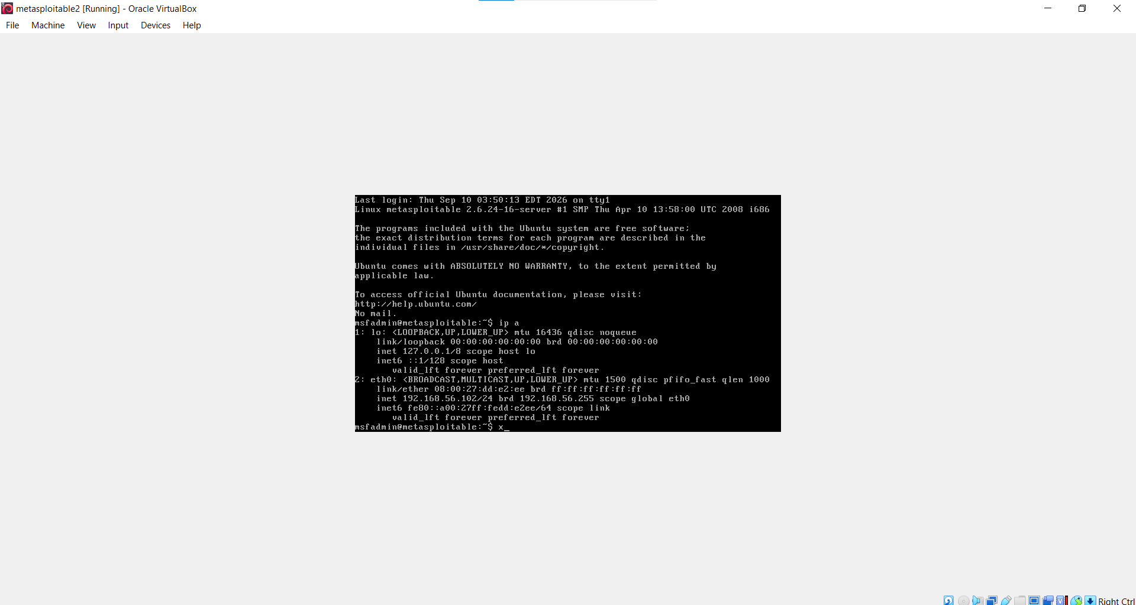

Figure 3: nmap scan result


